Group Name: The Best Group

Members: Gabe Glenn, Ben Paul, Jack Petry

Architecture Diagram:

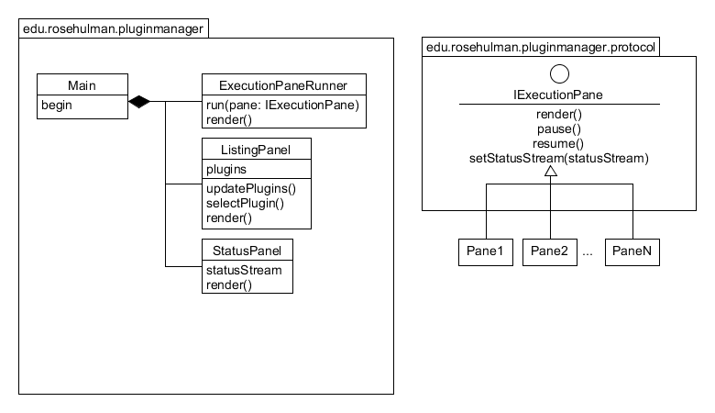

Feature Listing:

|  |  |  |  |
| --- | --- | --- | --- |
| F – 1 | Graphical Plugin Viewer | Creates a view that shows a graphical plugin found in the plugin directory | Gabe |
| F - 1 - 1 | Execution Pane | Shows the GUI of the plugin currently selected in the Listing Panel | Gabe |
| F – 2 | Plugin List View | Shows a list of available plugins | Jack |
| F – 2 – 1 | Plugin List Update | List adds/removes plugins from the list as they are added and removed from the plugin folder | Jack |
| F-3 | Status Panel | Messages can be posted to the status panel from either the base platform or any plugins. | Ben |
| F-4 | Plugin Installation | Plugins may be installed by adding them to the local plugins folder | Jack |
| F-4-1 | Plugin Uninstallation | Plugins may be removed by deleting them from the local plugins folder | Jack |
| F-4-2 | Plugin Loading | Plugins are loaded immediately from the plugins folder during runtime. | Jack |
| F - 4 - 3 | Plugin Execution | Plugins begin execution the first time they are selected, can be paused by selecting other plugins, and can then be resumed. | Ben |